**Hong Kong and Chinese Restaurants in London**

Wu Ka Yan Sophia

1. ovember 2020
2. **Introduction:**
   1. Background

More and more Hong Kong people are planned to immigrate to other countries due to the unstable political environment after Anti-Extradition Law Amendment Bill Movement in Hong Kong. UK would be one of the popular countries for immigration since Hong Kong was the colonies of UK before 1997 and the relaxed immigration policy to BNO holders. They think they are more familiar with British culture and have a lower boundaries with the relaxed immigration policy to BNO holders. More Hong Kong People immigrate to UK, the demand of Asian or Chinese restaurants would increase. Therefore, I would like to find out the location which is suitable for opening a Asianor Chinese restaurant in UK.

* 1. Target Clients

The UK local catering company and Hong Kong immigrants would be our main target client. UK local Chinese catering company can enlarge their business with the growing customer to Chinese cuisine from Hong Kong immigrants. Hong Kong immigrant can also invest in UK for the Chinese restaurant business which can bring the traditional Hong Kong Cuisine to the UK.

* 1. Business Problem and Problem Statement

To find out the location which is suitable for opening a Hong Kong or Chinese restaurant in UK

1. Districts with fewer chinese restaurant in order to build the reputation faster.
2. Districts with more low ranking restaurant in order to have less competition since we are targeting with the high standard of Traditional Hong Kong Cuisine
3. **Data and Methodology**
   1. Data Source

The analysis mainly contains of 2 main data source. The data of UK containing the districts name and districts' Latitude and Longitude coordinates is collected from <https://www.geodatos.net/en/coordinates/united-kingdom> . Moreover, Venue places with the information of location, name, categories in the UK would be collected from FourSquare. The frequency , venue type and rating would be saved in dataframe. Finally, Data visulization in different graphs sorted on venue rankings.

* 1. Data Cleaning

Geodatos has 20 rows and 2 columns in the raw dataset. Data is quite simple and clean which has no missing data, but Latitude and Longitude are in the same column. So, the coordinate would be slipted in to 2 columns in Latitude and Longitude accordingly

Foursquare data has 34 rows and 4 columns, and we retrieved more data for category, likes, tips and rating and finally become 6 columns. The data includes all 34 asian restaurant in UK.

* 1. Data Visualization
     1. The coordinate of the cities in UK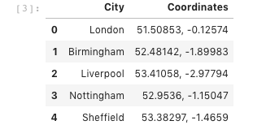
     2. The first 17 of Asian restaurant in UK in the list

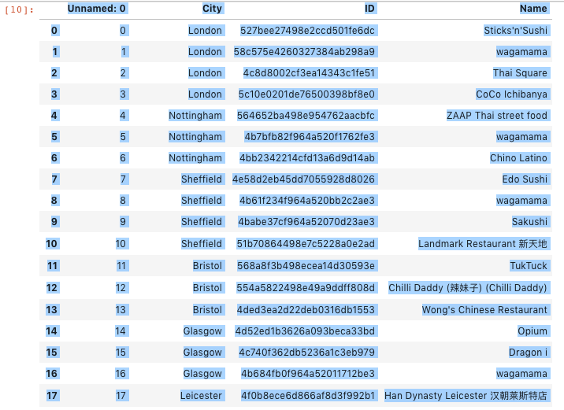

1. **Result and Discussion** 
   1. **How many Asian restaurant in UK?**

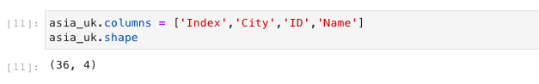

From the above chart showing that there are 36 Asian restaurants in UK

* 1. **Restaurant number over cities**

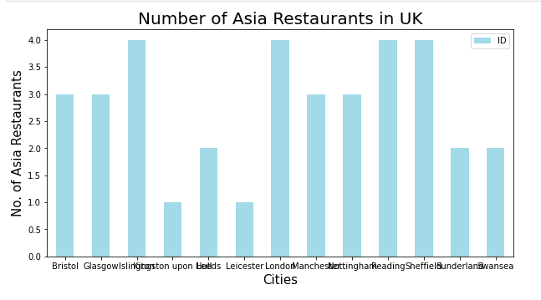

From the above chart showing that London, Reading, Sheffiel and Kingston are the cities has highest number of restaurant in UK.

* 1. **Top restaurants in Likes, rating, Tips Conclusion and Limitation**

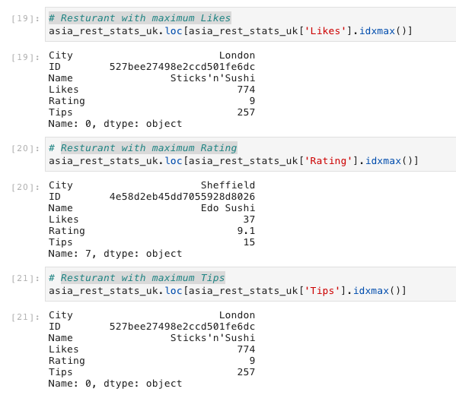

From the above chart showing that Restaurant with maximum Likes and maximum Tips is Sticks'n'Sushi in London. Restaurant with highest rating is Edo Sushi in Sheffield.

* 1. 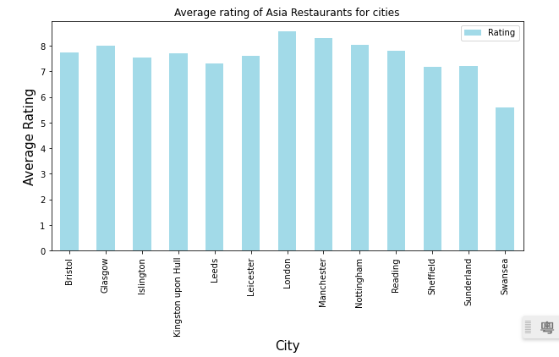 **Highest Rating over cities**

From the above chart showing that London has the highest rating in Asian Restaurant and Swansea has the lowest rating in Asian restaurant. The rating directly affecting the competition in that cities.

* 1. **Map of average rating over Cities**

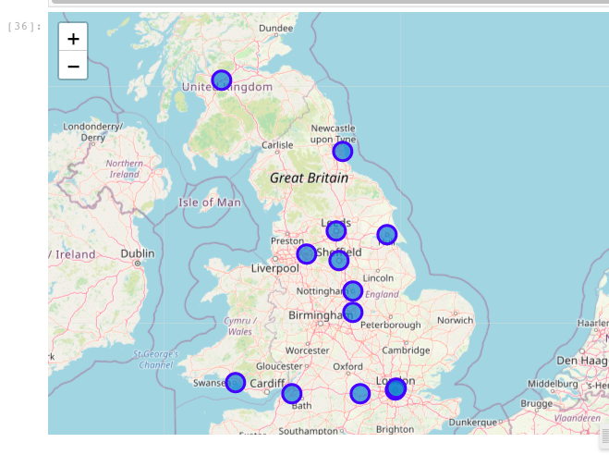

Blue dots are representing the average rating of the cities. Investors can be easier to spot out and select their target cities.

1. **Conclusion and Limitation**

In the UK, London and Manchester have relative high rate chinese restaurants in average. Swansea has lowest rate chinese restaurants in average. Restaurant with maximum Likes and maximum Tips is Sticks'n'Sushi in London. Restaurant with highest rating is Edo Sushi in Sheffield. Chinese restaurant only have 9 restaurant in the UK. It is the niche market for chinese cuisine. Sushi is easier to have a higher rating for the restaurant, but also in a higher competition.

In Conclusion, We would recommend the local catering company to open a Chinese restaurant in London and Manchester since they have more experience on local restaurant. But for Hong Kong immigrant would be suitable to open in Swansea with less competition to gain the reputation faster at the beginning.

Due to the limited data from Foursqaure, analysis cannot have a fully picture on the distribution of all restaurant in the UK. Further detail research and analysis have to made and more data from external database.